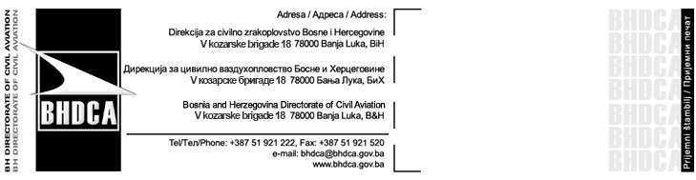
Zahtjev za 24-bitnu ICAO adresu zrakoplova (adresa Mode S koda)
ICAO 24 Bit Aircraft Address Request Form (Mode S Code Address)

Napomene / Notes:
- Mode S kod je neophodan samo za zrakoplove opremljene Mode S transponderom.
Mode S code is only necessary for aircraft equipped with mode S transponder.
- Pozivni znak mora već biti rezervisan za registraciju pri BHDCA.
Call sign must be already reserved for registration at BH DCA.
- Mode S kod će biti poništen nakon 6 mjeseci ako se zrakoplovom ne izvode operacije.
Mode S Code will be revoked after 6 month if aircraft is not operated.
- Ovaj zahtjev se može poslati na gore navedenu adresu.
This request form can be sent to the above noted address.

Operator / The Operator
Naziv / Name:
Adresa / Address:
Telefon / Phone Number:
E-mail (opciono) / Email (optional):

24-bitna ICAO oznaka zrakoplova / an ICAO 24 bit Aircraft designator
Datum / Date:
Naziv / Name:

Potpis / Signature:

