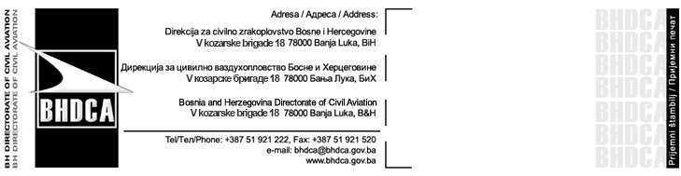
ZAHTJEV ZA PRIHVATANJE ODGOVORNOG OSOBLJA

(Application for Acceptance Nominated Post Holders)

Podaci o rukovodećem osoblju za koje se zahtijeva odobrenje u skladu sa zahtjevima više OPS dokumenata:
(Details of Management Personnel required to be accepted as specified in various OPS’s documents):
1) Ime i Prezime:
(Name and Surname):

2) Pozicija:
(Position):

3) Kvalifikacije značajne za tačku 2 – poziciju:
(Qualifications relevant to the item (2) position):

4) Radno iskustvo značajno za tačku 2 – poziciju:
(Work Experience relevant to the item (2) position):

Potpis: ……………………………………. Datum: ..........................................
(Signature): (Date):
Molimo Vas da ispunjeni obrazac pošaljete preporučenom poštom na adresu BH DCA:
(On completion, please send this form under confidential cover to the BH DCA):
Direkcija za civilno zrakoplovstvo Bosne i Hercegovine/The Bosnia and Herzegovina Directorate of civil Aviation
V kozarske brigade 18
78 000 Banja Luka

Organizacija: Potips:
(Organization): _________________________ Pečat (Stamp) (Signature): __________________

Pod punom materijalnom i krivičnom odgovornošću potvrđujem/o da su podaci navedeni u ovom zahtjevu i dostavljenim prilozima istiniti i tačni.
I hereby confirm, under full substantive and criminal liability, that the information supplied in this application and attachments submitted are true and correct.
Datum/Date: | Potpis(i)/Signature(s):

Napomena/Remark: Zahtjev ne može biti primljen bez dokaza o uplaćenoj administrativnoj taksi / Application cannot be admitted without evidence of payment of the administrative fee

Popunjava BH DCA
(BH DCA use only)
Ime i potpis ovlašćene osobe BH DCA za prihvatanje gore navedene osobe:
(Name and signature of authorized BH DCA staff member accepting this person):

Potpis: ……………………………………. Datum: ……………………………………….
(Signature): (Date):
Ime: ……………………………………….. Odjel: ………………………………………..
(Name): (Office):

